Date

Mr. Customer Name

Company Name

Address

City, State, Zip

Dear Customer Name;

As we discussed, please find enclosed a budgetary proposal for the ***New FoxJet High Resolution Ink Jet system.*** Please note that this large character ink jet solution includes all the hardware and software. This is a new state of art system featuring the Proven Reliable Trident Technology with the benefits of the FoxJet’s **A**utomatic **P**riming **S**ystem which is especially important in dusty environments. This cleaning process actually captures the dust particles that accumulate on the surface of the print-head face plate and vacuums the debris to a holding bottle. This cleaning process reduces the typical head cleaning requirements that you experience with your current systems.

The ***New FoxJet Marksman Elite Controller High Resolution Ink Jet System*** will replace your current technology. The Marksman Elite utilizes FoxJet’s intuitive BoxWriter software that runs on the industry standard Windows® operating system. Reliability has been built into the Marksman Elite with its easy to see industrial 17” touch-screen, solid state disk drive with no moving parts and Intel’s® Atom® based processor. It is all wrapped in a rugged type 304 stainless steel unique clam shell case that captures all the connectors inside to protect them from dust and moisture.

Please review the following proposal and contact me at your earliest convenience. I can be reached at XXX-XXX-XXXX. Thanks again for your continued interest in Distributor Name and FoxJet An ITW Company for the quality coding solutions that we are able to provide.

Sincerely,

# SALESMAN

SALESMAN”S Title

**FoxJet’s Marksman ELITE Controller**

**The Marksman ELITE is a flexible stand-alone industrial computer that is capable of operating up to four Pro Series 384e printheads for printing compliant barcodes, graphics, and/or alphanumeric characters on and corrugated cases and other porous materials.**

***Easy to Use – Fewer Operator Errors:***

* Industry leading 17” (43 cm) touch-screen for easy viewing of the print message
* Full QWERTY style on-screen keyboard that can be easily positioned to fit the operator
* Large icons that make it intuitive and easy for the operator to use

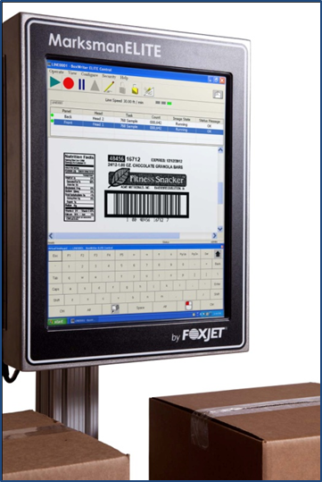***Reliability to the Extreme – Less Downtime:***

* Rugged stainless steel case, made from the same type of steel as used in the St. Louis Arch
* The case is unique in design that captures all connectors internally, keeping them free from exposure to moisture and dirt
* The ELITE has been designed with 50% few components than the previous model to improved reliability and uptime
* Utilizes a highly reliable and proven Solid State Disk (SSD)

***Flexible – Easily Fits Your Application:***

* Utilizes the BoxWriter software which operates on Microsoft’s® Windows® 7 platform for easy networking and sharing of data
* Customizable security schemes so that the data and functionality is available only to those that need it
* Easily configurable to control one or two packaging lines

***Easy on the Environment:***

* The system is compliant with RoHS, contains no hazardous materials It is energy efficient with Intel’s® low power Atom® processor and an SSD which consume about 1/3rd the power compared to the previous system.

***ProSeries 384 e***

**The ProSeries 384e enhanced printhead include the ink system, Priming System and print-engine that is capable of printing industry compliant barcodes, 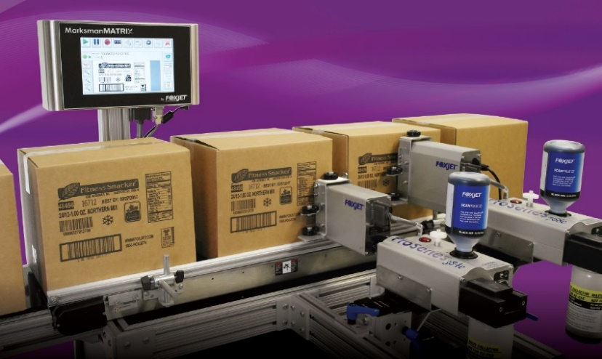graphics, and/or alphanumeric characters on and corrugated cases and other porous materials at up to 2” (50 mm) in height.**

***Low Operator Intervention:***

* Quick-Lock ink bottle for fast replacement of ink supply, the ink bottle can be changed while it is printing
* Automatic Priming System that handles most maintenance tasks

***Reliability to the Extreme – Less Downtime:***

* Rugged stainless steel nosepiece
* Automatic Priming System to maintain print quality throughout the life of the printhead
* The print engine was designed from the ground up for packaging applications and is backed by the longest warranty in the industry

***Flexible – Easily Fits Your Application:***

* With a 2” (50 mm) print height it fits many packaging applications
* With 192 dpi vertical resolution is can pint industry standard bar codes, text and graphics

***Economical:***

* With its adjustable horizontal resolution you can set it to use the minimum amount of ink for your application
* The Automatic Priming System can be adjusted to your operating environment to utilize the minimum amount of ink while maintaining top print quality
* The Average Mean Time Between Repairs is three years, the longest in the industry

|  |  |  |
| --- | --- | --- |
| KEY IMPROVEMENTS | Comparison to standard 384 | 384e  “The Barcode Printhead” |
| ***FASTER*** | Higher frequency /  higher print speed | 60% faster |
| ***FARTHER*** | Increased throw distance | Double |
| ***DARKER*** | Increased darkness of print | 15% darker |

* Improved barcode quality -Better barcode edges
* LED Ink Indicator – Visual indicator located on ink supply that warns the user of low ink or full waste bottle.
* DB25 Connector – Located at the rear of the print heads, eliminating the old style “pigtail” connection

**Trident’s ScanTrue**® **II Plus Ink**

**Trident’s ScanTrue II Plus is a pigmented black ink newly designed for the demands of high quality packaging applications. It is designed and manufactured to provide maximum performance and life from the ProSeries 384e printhead.**

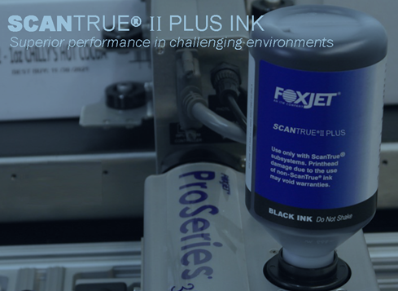

***ScanTrue II Features:***

* It minimizes ink bleed on porous surfaces for greatly improved bar code scanability
* Designed to meet the demanding requirements for narrow bar widths of the newer barcode symbiology’s
* Prints precisely with greater edge definition for clearer text and graphics
* Better light fastness, will not fade
* Excellent IR readability and scanning read rates for reliable bar codes

***Substrates/Applications:***

* Case coding
* Corrugated Bar code directly onto corrugated cartons or other porous substrates
* Prints high-quality verifiable UCC/EAN 128, I 2 of 5 and other tall bar codes

***Print Characteristics***

* Color: Black
* Ink type: Pigment, oil-based
* Shelf life: 18 months at room temperature
* Especially designed for Higher Humidity/Higher Temperature applications

**System Pricing**

FoxJet Marksman Elite Controller with (2) 384e Pro Series Printheads with Integrated Ink Reservoir and APS. This system includes:

* Hand-Held Scan and Shoot options for keyless, zero error message retrieval
* Integrated guide brackets with Tool-less x-y adjustments
* Floor mount controller stand with tilt bracket
* Three light alarm

**Here is a detail breakdown…**

|  |  |  |
| --- | --- | --- |
| **QTY** | **PART NUMBER** | **DESCRIPTION** |
| 1 | 2465004D2 | Marksman *Elite* Dual Head Controller |
| 2 | 2464076 | ProSeries 384e Printhead w/APS, Scan True II Black Ink |
| 2 | 2464561 | Bracket, Dual Axis Tool-less Printhead Adjustment (Requires 2454-550) |
| 2 | 2464565 | Integrated Guide System for Modular ProSeries 384/768 |
| 1 | 2465243 | Marksman Elite/Matrix T-Base Controller Mounting Stand |
| 2 | 2465155-010 | Printhead Cable Kit, 10' for All ProSeries Printheads |
| 1 | 5760820-IJ | Mk Encoder Assembly w/ Mounting Bracket |
| 1 | 2465224 | Teach Photosensor w/ Mounting Bracket for ProSeries 384/768 |
| 1 | 2465154 | Hand-Held Scanner for Print Task Start |
| 1 | 2465253 | Alarm Tower, Three Color |

**Final Equipment Cost $XXXXXXXX**

**Inks and Maintenance**

|  |  |  |
| --- | --- | --- |
| **PART NUMBER** | **DESCRIPTION** | **PRICE** |
| 001-0961-01F | INK, 500ML SCANTRUE II PLUS | $ 245.00 |
| 9001-0443-01 | CLN SOLN. MAINT SPRAY ST2 PK/4 SCANTRUE II | $ 140.00 |
| 5760832 | Lint Free Swabs for ProSeries Impulse Heads (100/Pack) | $ 65.00 |

**Installation & Training**

Installation and training costs are $XXXX .XX for the first system, $XXX.XX for additional systems installed at the same time.

**Payment Terms**

Net XXXX Days upon receipt of invoice

F.O.B.: FoxJet – St Charles, MO

Delivery: 2-3 Weeks

**Warranty Support**

FoxJet offers a one year parts warranty to protect you against premature failure of parts. An extended warranty of up to three years on parts in available. Contact your authorized FoxJet distributor or visit FoxJet’s web site [www.foxjet.com](http://www.foxjet.com) for complete details.

Distributor offers a 90 day onsite labor warranty…Standard Warranty

All FoxJet Parts have a one year warranty; please visit [www.foxjet.com](http://www.foxjet.com) for warranty details.